**CSA1143 – Object Oriented Analysis and Design**

***Name:*** Benny Steward S

***Register No:*** 192011033

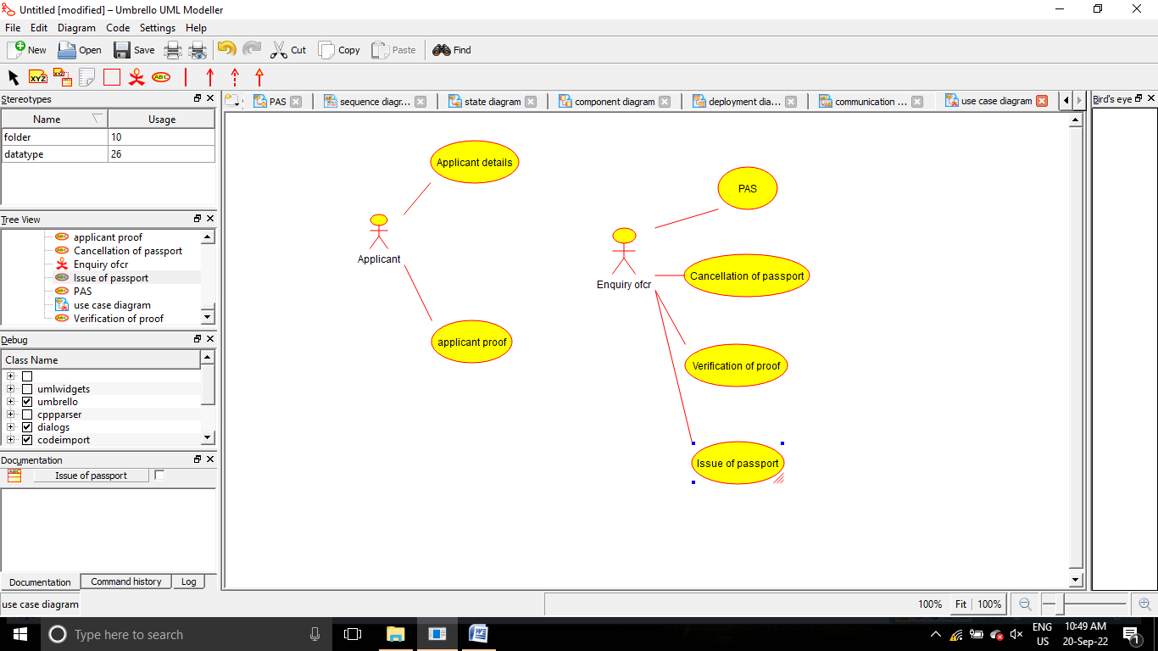

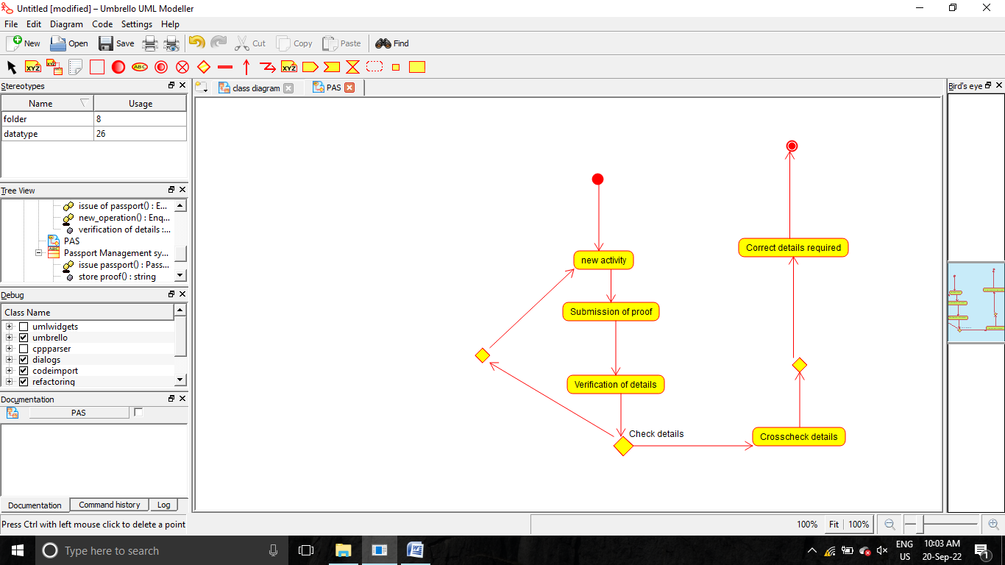

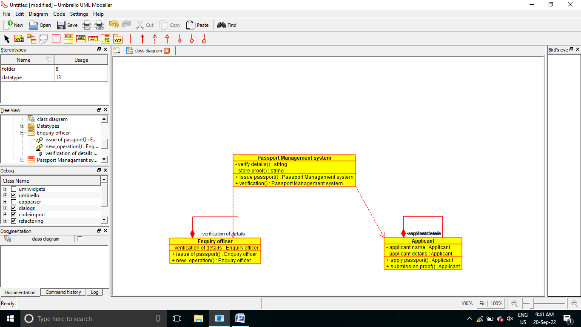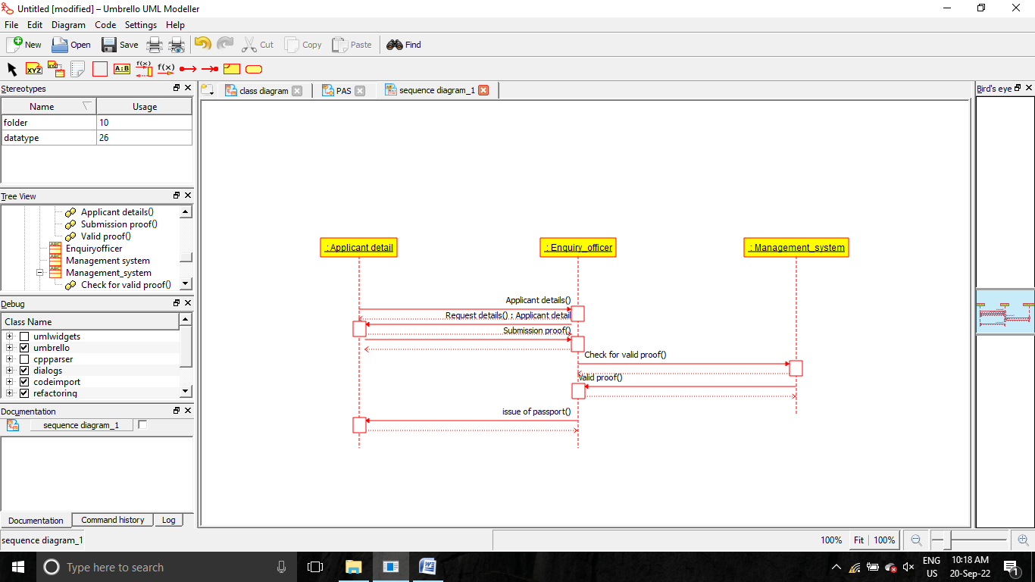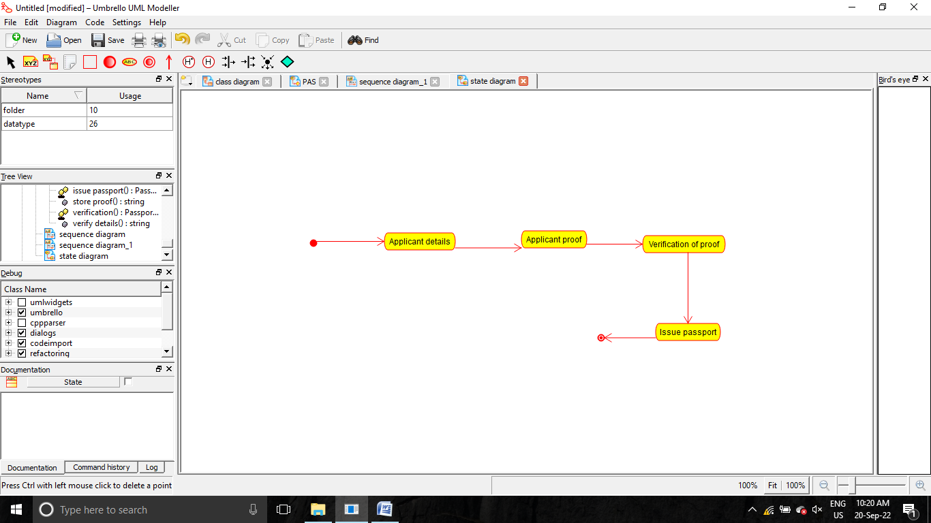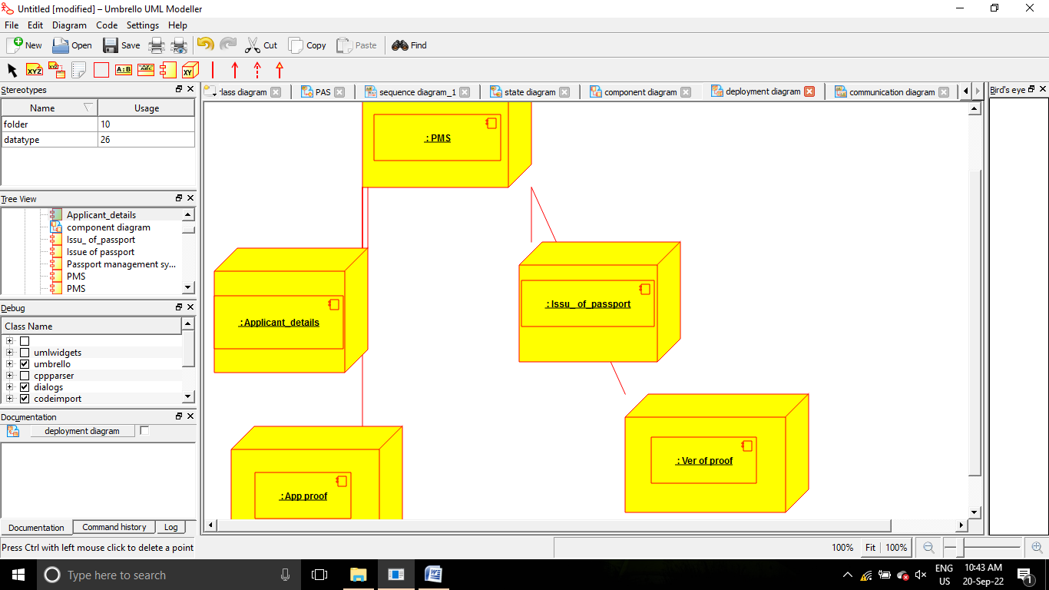

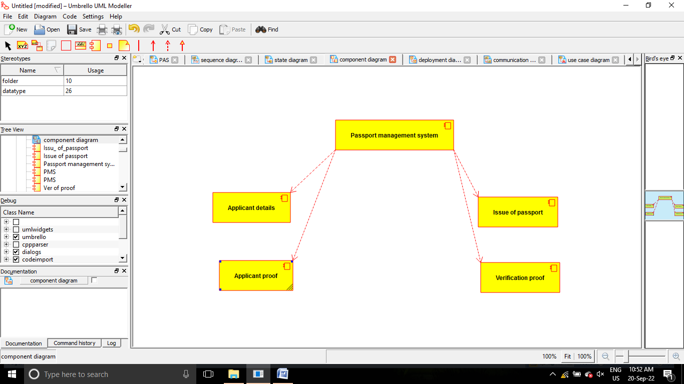

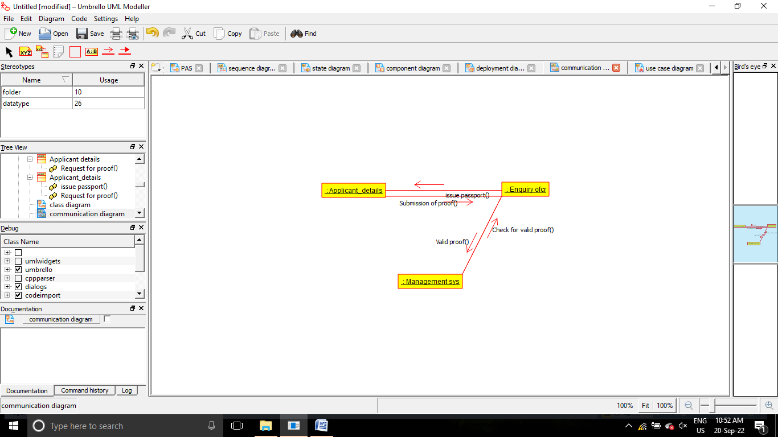

/**

 * Class Applicant

 */

public class Applicant {

  //

  // Fields

  //

  private Applicant applicant_name;

  private Applicant applicant_details;

  //

  // Constructors

  //

  public Applicant () { };

  //

  // Methods

  //

  //

  // Accessor methods

  //

  /**

   * Set the value of applicant_name

   * @param newVar the new value of applicant_name

   */

  private void setApplicant_name (Applicant newVar) {

    applicant_name = newVar;

  }

  /**

   * Get the value of applicant_name

   * @return the value of applicant_name

   */

  private Applicant getApplicant_name () {

    return applicant_name;

  }

  /**

   * Set the value of applicant_details

   * @param newVar the new value of applicant_details

   */

  private void setApplicant_details (Applicant newVar) {

    applicant_details = newVar;

  }

  /**

   * Get the value of applicant_details

   * @return the value of applicant_details

   */

  private Applicant getApplicant_details () {

    return applicant_details;

  }

  //

  // Other methods

  //

  /**

   * @return       Applicant

   */

  public Applicant apply_passport()

  {

  }

  /**

   * @return       Applicant

   */

  public Applicant submission_proof()

  {

  }

}

/**

 * Class Enquiry_officer

 */

public class Enquiry_officer {

  //

  // Fields

  //

  private Enquiry officer verification_of_details;

  //

  // Constructors

  //

  public Enquiry_officer () { };

  //

  // Methods

  //

  //

  // Accessor methods

  //

  /**

   * Set the value of verification_of_details

   * @param newVar the new value of verification_of_details

   */

  private void setVerification_of_details (Enquiry officer newVar) {

    verification_of_details = newVar;

  }

  /**

   * Get the value of verification_of_details

   * @return the value of verification_of_details

   */

  private Enquiry officer getVerification_of_details () {

    return verification_of_details;

  }

  //

  // Other methods

  //

  /**

   * @return       Enquiry officer

   */

  public Enquiry officer issue_of_passport()

  {

  }

  /**

   * @return       Enquiry officer

   */

  public Enquiry officer new_operation()

  {

  }

}

/**

 * Class Passport_Management_system

 */

public class Passport_Management_system {

  //

  // Fields

  //

  private String verify_details_;

  private String store_proof_;

  //

  // Constructors

  //

  public Passport_Management_system () { };

  //

  // Methods

  //

  //

  // Accessor methods

  //

  /**

   * Set the value of verify_details_

   * @param newVar the new value of verify_details_

   */

  private void setVerify_details_ (String newVar) {

    verify_details_ = newVar;

  }

  /**

   * Get the value of verify_details_

   * @return the value of verify_details_

   */

  private String getVerify_details_ () {

    return verify_details_;

  }

  /**

   * Set the value of store_proof_

   * @param newVar the new value of store_proof_

   */

  private void setStore_proof_ (String newVar) {

    store_proof_ = newVar;

  }

  /**

   * Get the value of store_proof_

   * @return the value of store_proof_

   */

  private String getStore_proof_ () {

    return store_proof_;

  }

  //

  // Other methods

  //

  /**

   * @return       Passport Management system

   */

  public Passport Management system issue_passport()

  {

  }

  /**

   * @return       Passport Management system

   */

  public Passport Management system verification()

  {

  }

}